




Application Guide

BETASEAL™ Ezi-Gun® adhesive is available in 400ml sausages. It is very important to protect yourself and the customer’s vehicle.

Wear appropriate Personal Protection Equipment, including chemical-resistant nitrile gloves, eye protection, Cut resitance gloves, Cut resistance sleves and safety boots.

Consult Material Safety Data Sheets and familiarise yourself with all relevant health information and safety procedures for BETASEAL™ Ezi–Gun® adhesive. Follow OEM application manual of the respective make and model.

Required materials: Cutting-out equipment, Trimming knife, Glass Suction Lifters, Quality Paper Cleaning Cloth, Primer Applicators, Ezi Clean Surface Preparation Cleaner, Windscreen Stand and an Adhesive Applicator Gun. Ensure all products are within shelf life or open-time limitations. When opening new primer, note the date of opening on the bottle. Check the Argic code to ensure the glass specification is correct. | 
1. Remove all mouldings, rearview mirror, trims and wipers, and disconnect all electrical devices and cowlings that could be impacted by cut out and installation. Open vehicle side windows and cover adjacent external and internal surfaces. | 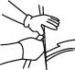
2. Cut through the existing glass bond line using your preferred method, taking care not to damage the vehicle or any electrical systems or cables. | 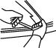
3. Dry fit the glass after safe removal of existing glass. Make sure the new glass fits properly and the glass is free from defects. | 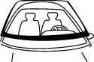
4. Prepare the vehicle aperture. If the residual PUR bead is sound and stuck firmly, trim it back to a height of 1-2 mm to provide a clean, level and secure surface for rebonding. Take care not to damage paint. Clean the aperture with Ezi Clean Surface Preparation Cleaner, wipe on / wipe off using a quality paper cloth. | 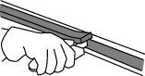
5. Check for corrosion. If necessary, grind/abrade any corrosion in and around the bond line area down to bare metal, clean with Ezi Clean Surface Preparation Cleaner, wipe on / wipe off using a quality paper cloth.  For larger damaged area, repair at a body shop may be required. | 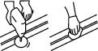
6. Apply BETAPRIME™ 5504 primer to bare metal.  Apply two coats of primer to build up protection, with a minimum of 1 minute between coats. Allow the second coat to flash off a minimum of 2 minutes | . 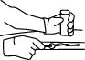
7. No priming is necessary if PU cut-back bead is firmly secure to the body aperture and freshly trimmed (up to 2 hours). If the remaining PU bead is insecure or missing, then prime the aperture bondline with BETAPRIME™ 5504 primer. Apply primer using a felt applicator in a single even coat. Take care with trim-less glass to only prime areas not seen once installation is complete | 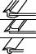  .
8. Remove any glass contamination with BETABRADE™ F1. Apply a thin bead around the ceramic bond-line area and wipe off with a good quality cloth. Neutralise any remaining BETABRADE F1 residue by applying Ezi Clean Surface Preparation Cleaner around the glass. Wipe clean and dry with a good quality cloth. | 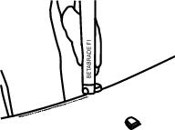  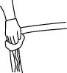
9. Prime glass ceramic with BETAPRIME™ 5504 primer Apply primer using a felt applicator in a single even coat..Note: For RIM and PUR pre-applied encapsulations, if encapsulations fall within the bond line, it may be necessary to clean with Ezi Clean Surface Preparation Cleaner and dry with a good quality cloth prior to priming. Allow primer to flash off for 2 minutes. | 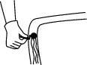
10. If necessary, fix continuous trim around the glass prior to installation. Be careful not to damage or contaminate the primer film. | 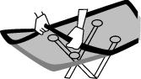
11. Apply BETASEAL™ Ezi–Gun® adhesive at the bottom of the aperture, using a pre-cut triangular nozzle, ensuring the new adhesive is applied over the old remaining bead where applicable. Hold the applicator gun at a near-90° angle to ensure a high triangular bead.  A single-only joint is preferred. Always check that the joints in the PU bead forms a complete bead, with no gaps or air pockets. | 
12. Affix the glass to the body immediately after extrusion.  Take care to position the glass with minimal alignment. | 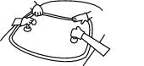
13. Compress the glass to the correct height within the aperture. | 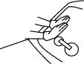
14. Reconnect all electrical sensors and other driver-assist systems.  Reinsert mouldings, rearview mirror and trims, secure all cowlings under the bonnet and affix wipers. Check that all systems work correctly.  Clean up. Remove all protective covers from vehicle interior and exterior. Clean glass with Ezi Clean Surface Preparation Cleaner, using a quality paper cloth | 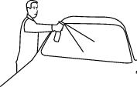
15. Record and hand back after correct minimum safe drive-away time. Record time, display and inform vehicle owner of minimum safe drive-away time. Record all product batch numbers on job card using labels provided, to ensure full traceability. Complete paperwork and hand back keys to customer. | 